|  |  |  |
| --- | --- | --- |
| **SOP Name/Title:** | | |
| **Document Storage Location/Source:** | | **Document No:** |
| **SOP Originator:** | **Approving Position:** | **Effective Date:** |
| **Name:** | **Name:** | **Last Edited Date:** |
| **Signature:** | **Signature:** | **Other:** |

### Purpose

### Scope

### Responsibilities

### Materials

### Related Documents

### Definitions

### Process Map

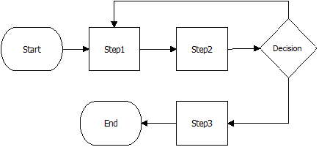

### Procedures

|  |  |  |
| --- | --- | --- |
| **Step** | **Action** | **Responsible** |
| 1 |  |  |
| 2 |  |  |
| 3 |  |  |

### Process Metrics

### Resources